**BHARATA MUNI**

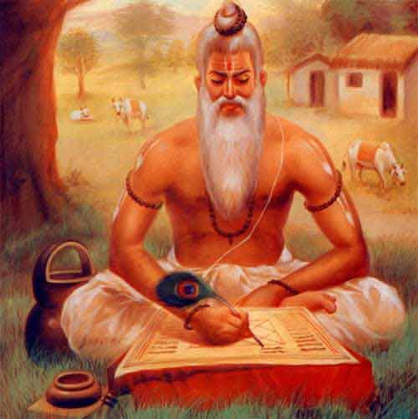

* SAGE BHARATA is the father of Indian theatrical arts and musicologist who authored the Natya Shastra. Indian drama, dance and music find their root in the Natyashastra.
* He was born in Kashmir between 200B.C and 400B.C. but some historians place him between 1000 and 500B.C.
* According to some critics he was a follower of Kashmir Shaivism.
* He is also said to have collected all the material of earlier acharyas (ancient teachers) like Tumburu, Narada and Nandi and gave the Natyashastra a complete coherence by making additions, alterations and adaptations.
* There was quite a large number of commentaries on the Nayashastra of Bharata.
* But all of them are unfortunately lost, except the Abhinava Bharata of Abhinavagupta.
* Besides Abhinavagupta, there are only three commentators.
* The earliest commentator of the Natyashastra is Lolata who gives the theory of the aropevada (attribution).
* Shankuka happens to be the second commentator of Bharata.
* The third commentator of Bharat is Acharya Bhattanayayaka who gave the theory of bhuktivada (theory of taste) based on sadharanikarana (generalization).
* The next renowned exegete of Bharata is Abhinavagupta of roughly later half of the 10th and first half of the 11th C.E.
* His concept of rasa has a profoundly philosophical basis.
* His concept of atmaprakasha (self-consciousness) is the expansion of Shaiva philosophy in which Paramashiva is equated with atma (soul) equipped with prakasha (light)
* The other comentators were bhattanayaka, Rahula, BhattaTauta , Kirtidhara, Vamadeva, Matrigupta etc.

**Natyashastra**

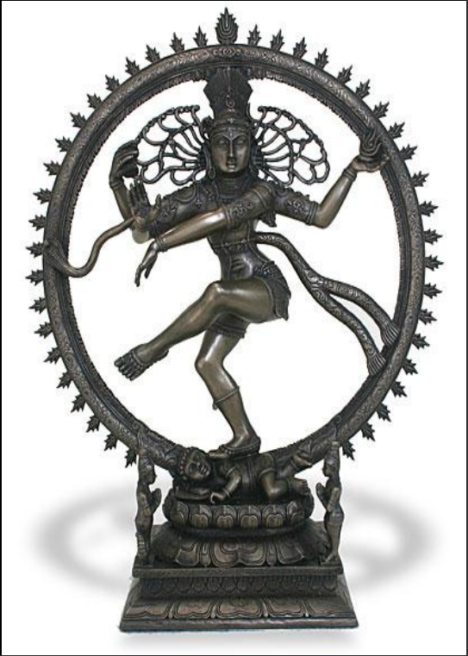

* The Nayashastra known as Natyaveda or the fifth Veda, is a classical manual on the theory and practice of Indian aesthetic theatre, music, dance, poetics, gestures and many other allied arts given by Bharata Muni.
* The Nayashastra primarily aims at giving the necessary directions to actors.
* It also aims at helping the aesthete, who is eager to enjoy the beautiful and afraid of the study of the Vedas and Puranas, which show the ways of realization of the main objectives of human life.

**Date of Composition**

* 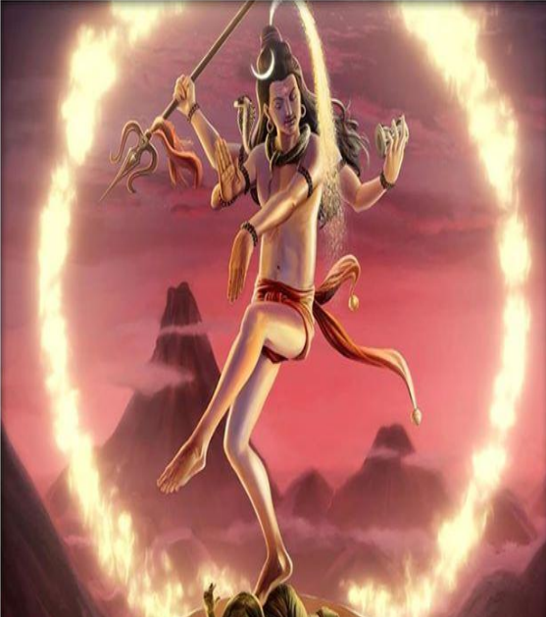As far as the date of this work is concerned, there are two views based on religious belief and linguistic analysis and references to decide the date of this work.
* According created by Brahma, in compliance with the request of the gods to the religious view.
* It is also believed that Brahma took the element of song from the Samaveda, the tandava (vigorous dance) from Shiva, the lashya (grace)from Parvati and compiled the Nayashastra.
* As regards the view based on linguistic analysis The scholarly opinion varies placing it anywhere from 2nd century B.C.E. to 2nd century.

**Division of Natyashastra**

* Based on the manuscript of the Abhinavabharati, a commentary of Abhinavagupta (11th century C.E.), is divided into thirty-six chapters.
* In general,there are eleven topics that are covered in the Natyasastra.
* They are : “Rasa(sentiments),Bhava(emotions),Abhinaya(acting) , Dharmi(practices of performance),Vritti (styles),Pravritti (regional styles),Siddhi (achievement),Swara ( notes),Atodya (instrumental music),Gana (singing)&Ranga (stage)
* The rasas are nine, bhavas are 49 ,abhinaya is of four types, the practices are two, four are the styles, pravritti - 4, siddhi - 2, swara - 7, atodya - 4, gana - 5 types, ranga are of three.
* There are nine types of rasa:-adbhuta, karuna, rowdra, veera, sringara, hasya, bhayanaka, bhibatsa and shanta.

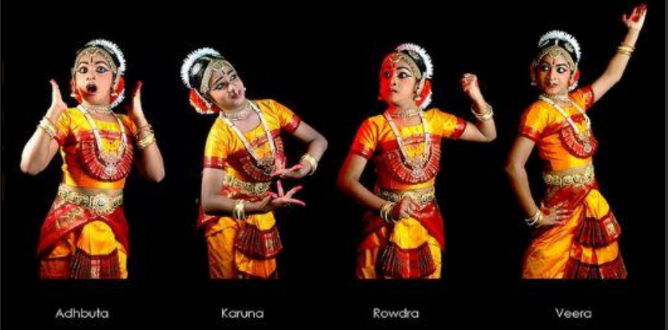

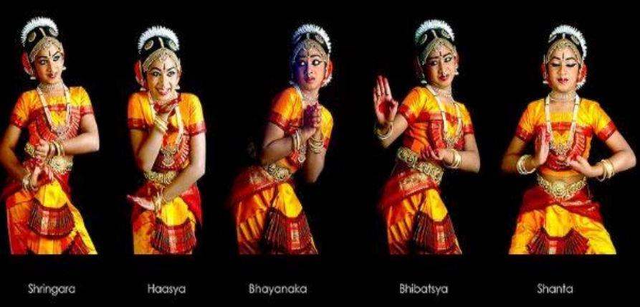

* Four kinds of abhinayas (acting/ expression) :
* angika abhinaya (bodily expression),
* vacika abhinaya (linguistic expression,
* aharya abhinaya (costumes of the characters and stage decoration),
* sattvika abhinaya (voluntary changes expressed by the presence of tears, mark of horripilation, change of facial color, trembling of lips, enhancing of nostrils) to express the deepest emotions of a character.
* Two kinds of dharmis (theatrical representations) :
* lokadharmi (artistic representation of the ordinary world or the real life) and
* natyadharmi (artistic representation of the imaginary worlds like svarga (heavens).
* Four kinds of vrittis (modes of productions) :
* bharati (dominance of spoken contents)
* kaishiki (dominance of dance and music)
* sattvati (dominance of elevated and heroic feelings) and
* arabhati (dominance of violent and conflictual actions)
* The four pravrittis :
* avanti,
* dakshinatya,
* panchali and
* magadhi (the tastes of audiences in various parts of India)
* Four kinds of atodyas (musical instruments used on the stage); ganam or dhruvas (songs sung in the course of dramatic action at five junctures :
* praveshiki (song sung before the entry of a character),
* naishkramiki (song sung to sooth emotions of the audience after a very moving or shocking scene),
* akshepiki (song sung to create an intervention) and
* antara (song sung in between episodes to entertain the audience)
* The primary purpose of this work is a blissful mental state.
* Bharata thus proclaims:This natya will be the cause of bliss to all those poor beings who are afflicted by difficulties,hardships and sorrows